FORMAL ANALYSIS #1

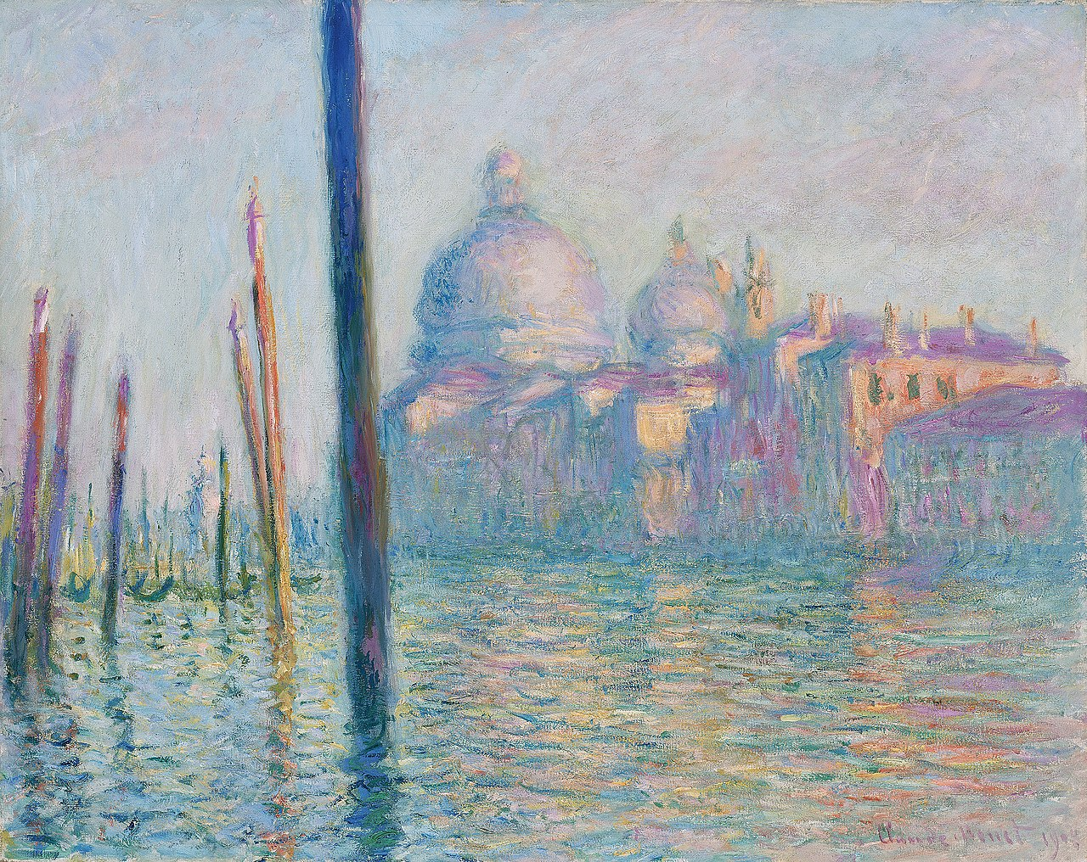

*Fig. 1. Claude Monet, Le Grand Canal, 1908. Oil on Canvas, 92.4cm x 73.7cm. Boston: Museum of Fine Art.*

Le Grand Canal

1. What is your gut response to your selected object? ­­­­­­­­­­­­­­­­­­

Soft.

1. List 12 observations about the work of art in bulleted format – essentially, answer the question “What do you see?”

* Reflective water in the foreground with soft ripples.
* Scene presented without a lot of definition; objects pained in a blurred fashion to highlight color scheme.
* Warm orange light casting from right side of the scene
* Darkened portions of the scene portrayed in purple, blue and green color scheme.
* Domed church and exterior buildings in the background, acting as the main feature covering the far-right side.
* Pillars rising from up background to foreground emerging out of the water.
* Water painted with grainy wavy strokes with layered colors to depict, reflection, light and movement.
* Venetian gondola’s seen through the pillars grouped and tied off
* Depth of pillars through scene present a three-dimensional view, with shadows casted on water.
* Contrasting colors and curved brush strokes give the water a dynamic view with slight movement.
* Church and exterior buildings directly on waterfront with colors reflecting towards viewer.
* Open space present throughout, right foreground undisturbed of any features besides water.

1. Now review your gut reaction and your observations. For this first formal assignment, you are writing a draft “visual analysis” essay of 1-3 paragraphs that incorporates the information about the formal composition of the object. How do your gut reaction and observations work together? Can you see a way that your visual observations support your gut reaction, and the way in which the artist has used the medium to create certain effects?

For the first formal analysis I choose to analyze Claude Monet’s Le Grand Canal. Le Grand Canal was painted in 1908 by oil on canvas and was one of thirty-seven canvases Monet painted of Venice. Venice was a city he originally depicted as “too beautiful to paint” [1], till he received an invitation from an American friend to stay in a palazzo on the Grand Canal. In Le Grand Canal, Monet portrays the Salute church while looking down the Grand Canal. This 92.4cm x 73.7cm painting is portrayed at the Museum of Fine Arts in Boston and in 2015 sold for more than $35 million dollars. I chose to analyze Le Grand Canal for its color scheme and painting style, also because I recently viewed it on a trip to Boston. The impressionism painting movement always struck me as beautiful, from Claude Monet’s work here to other artists such as Vincent van Gogh’s post-impressionist work.

Although only having briefly covered impressionism in art classes in high school, the first observation I made speaks directly to the reflective qualities present. Impressionism puts and “emphasis on accurate depiction of light in its changing qualities” [2]. Monet’s ability to portray reflection and contrasts in light depictions become the focus, with non-conventional colors showing light and shadow with orange and green respectively. Compared to hyper-realism, this painting maintains its beauty by its ability to show details in its color. Some examples are a simple dark green crescent brush stroke becomes a Venetian gundalow and horizontally staggered orange strokes on the top of a building become illuminated chimneys.

Impressionism is also “characterized by relatively small, thin, yet visible brush strokes” [2]. This stood out to me as I mentioned Le Grand Canal’s water was painted with grainy wavy strokes. Although difficult to see on a computer, when viewed in a gallery, Le Grand Canal painting’s appearance transitions depending on viewing distance. Due to the visible brush strokes, the painting is messy and scattered when viewed too close. Talking a few steps back allows the viewer to admire how the combination of colors and strokes blend to create an impressive scene. Overall the connections between my gut reaction and initial descriptions closely coincide with the values of impressionism. Personally, this only speaks to Claude Monet’s incredible ability to present these values through his work and capture the artists attention.

References

1. Grand Canal, Venice – Works – Museum of Fine Arts, Boston, Museum of Fine Arts, Boston, collections.mfa.org/objects/31790/grand-canal-venice?ctx=b79754b3-3ec5-44d5-a105-3386016166c3&idx=33.
2. “Impressionism.” Wikipedia, Wikimedia Foundation, 6 Feb. 2020, en.wikipedia.org/wiki/Impressionism.